George Mason University

Deforestation Rate of Change in the Amazon Rainforest

Rachael Nicoletta

GGS 416

Dr. Edward Oughton

02 December 2022

**Abstract**

The purpose of this research was to calculate the average rate of vegetation change from deforestation. More specifically, the research question that this study addressed was which part of the deforestation process experienced the most change. The Brazilian Amazon is an adequate source to pull deforestation data from due to widespread reports on deforestation practices occurring here so the land samples for this research were from a recently deforested area in Brazil. Ultimately, the land area experienced the most change in the earlier and later stages of the deforestation process, but the results were skewed due to clouds and more experiments should be done with a larger and less cloudy time series of images. The results were discussed in terms of the average rate of change values of the Normalized Difference Vegetation Index throughout the time-series and the implications of the clouds and time gaps.

**Overview**

In a press release from the Intergovernmental Panel on Climate Change (IPCC), a governing research source providing critical science backed research on climate change for the United Nations, land conversions and management play a significant role in the release of greenhouse gas emissions and climate change (*Chapter 1*, n.d.). Thus, facilitating better land use practices is a goal for the Paris Climate Agreement, an agreement made by joined nations to limit global warming to below 2°C through strategic action with various stakeholders such as the energy, transportation, infrastructure, and agricultural sectors. In addition to the IPCC’s statements on land use, other studies have also critically analyzed the scope of land use change and found greater results than previously estimated. One study on shifting cultivation found that over 280 million hectares of land are experiencing shifting cultivation than the estimated 1 million (Heinimann et al., 2017). Additionally, a more recent study on land use change utilized multiple data resources such as remote sensing, reconstructions, and statistics to assess global land use change through their Historic Land Dynamics Assessment + (HILDA +). Ultimately, they discovered that land use change affected 32% of the world’s land between 1960 and 2019, which is larger than previous land use change assessments had predicted by four times (Winkler et al., 2021).

Land use change is broad and not all changes in landscape are equal, which is an important consideration for determining which form of land should be evaluated for researching deforestation. Tree cover in specific has experienced a net decline of 2.4% between 2000 and 2020 (Vizzuality, n.d.). In addition to knowing which land to focus on, having access to land data sources such as satellite imagery is also important. Satellite imagery is an effective tool in showing environmental destruction and curating solid evidence for holding environmental offenders accountable (Kshetri et al., 2020). This study discussed how satellite imagery can also be used to analyze events over a given amount of time and claimed that environmental activists were able to utilize this while working with policymakers to act against environmental offenders.

The Brazilian Amazon has experienced significant losses in biodiversity considerably because of deforestation, with an 80% reduction within the past decade as of a 2016 research study. The same study indicates that “tipping points” have been modeled for the Amazon that would result in a “savannization” of the southern and eastern Amazon if the temperature reached 4°C or the deforestation surpasses 40% (Nobre et al., 2016). Brazil, which contains a significant portion of the Amazon Rainforest, experienced a 12% decrease in tree cover between 2000 and 2021 (Global Forest Watch). Hence, this research will focus on deforested areas in the Brazilian Amazon Rainforest due to the abundance of data here, particularly which period in the deforestation process experiences the most change. Due to the increasing scale of deforestation in the Amazon, as previously discussed, understanding this average rate of change can be influential for stakeholders living near or occupying this deforested land.

**Literature Review**

**Causes**

Understanding the causes of deforestation and their scope and effects on the Amazon is important as these considerations will need to be kept in mind when analyzing the land sample results. There are numerous causes for deforestation in the Amazon such as livestock, agriculture, mining, and burning which presents a potential threat to the rainforest if the more destructive contributors are not managed (Oliveira et al., 2020). Animal agriculture is one major contributor particularly because land is needed for cattle grazing as well as growing food to feed the cattle. Animal agriculture has become prominent, for example, in Mato Grosso, Brazil, where a study found a 29% increase in slaughterhouse plants between 2000 and 2016 by utilizing satellite imagery, government records, and a registry of companies to map slaughterhouse locations (Vale et al., 2019).

Considering the vastness of the Amazon across multiple countries in South America, there are many stakeholders effected by its development and so politics have some influence. The colonization of the Amazon on such a mass scale has sparked concern over deforestation. A strong understanding of climate change and science is important for developing strong environmental policies (Monteiro et al., 2014). Not having strong environmental policies opens the door for careless land usage which can present serious consequences to the overall health of the Amazon and its inhabitants. Illegal deforestation exists primarily through large criminal networks and corruption from geoprocessing experts, police, and public officials. Although not focused solely on the Amazon, this study in Latin America estimated that up to 84% of deforestation is illegal and suggests some interventions to combat these criminal activities such as monitoring and law enforcement (Bolton, 2020).

**Implications**

Deforestation presents numerous threats to the environment, animals, people, particularly indigenous groups, and overall health of the biodiversity in the surrounding areas. Shifting cultivation has a lasting impact on land cover types, and one study in Papua New Guinea experienced forest area loss as urban areas increased between 2010 and 2020 (Doaemo et al., 2020). This is an important consideration to keep in mind for land holders in the Amazon intending on developing urban areas and the sacrifices this will have on the forests. Rivers near deforestation sites are at risk of contamination and disruption which is consequential in areas running along it and utilizing it. Current approaches studying deforestation’s effects on river flow conflict with each other, with one study concluding that deforestation does not help improve river flow, thus contradicting other studies (Posada-Marín & Salazar, 2022). On the topic of flow, land use change can also affect the migratory patterns of animals. One study used satellite imagery to analyze the migration of African elephants and found that these changes threatened most of the identified migration avenues for larger animals (Schüßler et al., 2018). This complicates sustainable land use planning and conservation efforts that attempt to protect specific species in the Kenyan Tanzanian borderlands and presents another consequence of deforestation.

Lastly, deforestation presents challenges for indigenous communities such as land violation conflicts and health concerns. Due to the Amazon Rainforests critical role in climate regulation, forest loss is worsening its ability to regulate this and is contributing to the global rise of temperatures and thus becoming a driver of emerging diseases (Ellwanger et al., 2020). These diseases are further exacerbated by deforestation efforts and are a concern for public health. Additionally, the practices used in the deforestation process such as burning, portrays another potential threat to the public health (Urrutia-Pereira et al., 2021). The study claims there is not sufficient research on the topic of deforestation smoke and public health, but this is another public health concern to consider especially for areas in the rainforest intended to be used for urban development. Indigenous lands, which make up 21% of the Brazilian Amazon, are also threatened by deforestation, particularly due to insufficient enforcement of Indigenous rights and changing economic and social factors (Le Tourneau, 2015).

**Solutions**

There are numerous solutions to fight forest fires and assist in global restoration efforts, but this requires financial and political support. According to one study on global tree planting projects, forest restoration reduces climate change, desertification, and helps preserve the natural vegetation in regional tropical and global environments if the wood used in the deforestation process is reused elsewhere rather than burned (Peng et al., 2020). More technical solutions such as remote sensing and monitoring the Earth and analyzing its various states can help us detect land use changes (McDowell et al., 2015). This is more relevant for this research project because multiband satellite images will be used, particularly the red and NIR bands to analyze the vegetation in the images. Pre and post fire land areas can be distinguished by using the NDVI as was done for one study on vegetation recovery at two test fire sites in Spain and Greece (Lanorte et al., 2014). This is also relevant because the NDVI will be used on the time series of images to analyze vegetation patterns.

**Methodology**

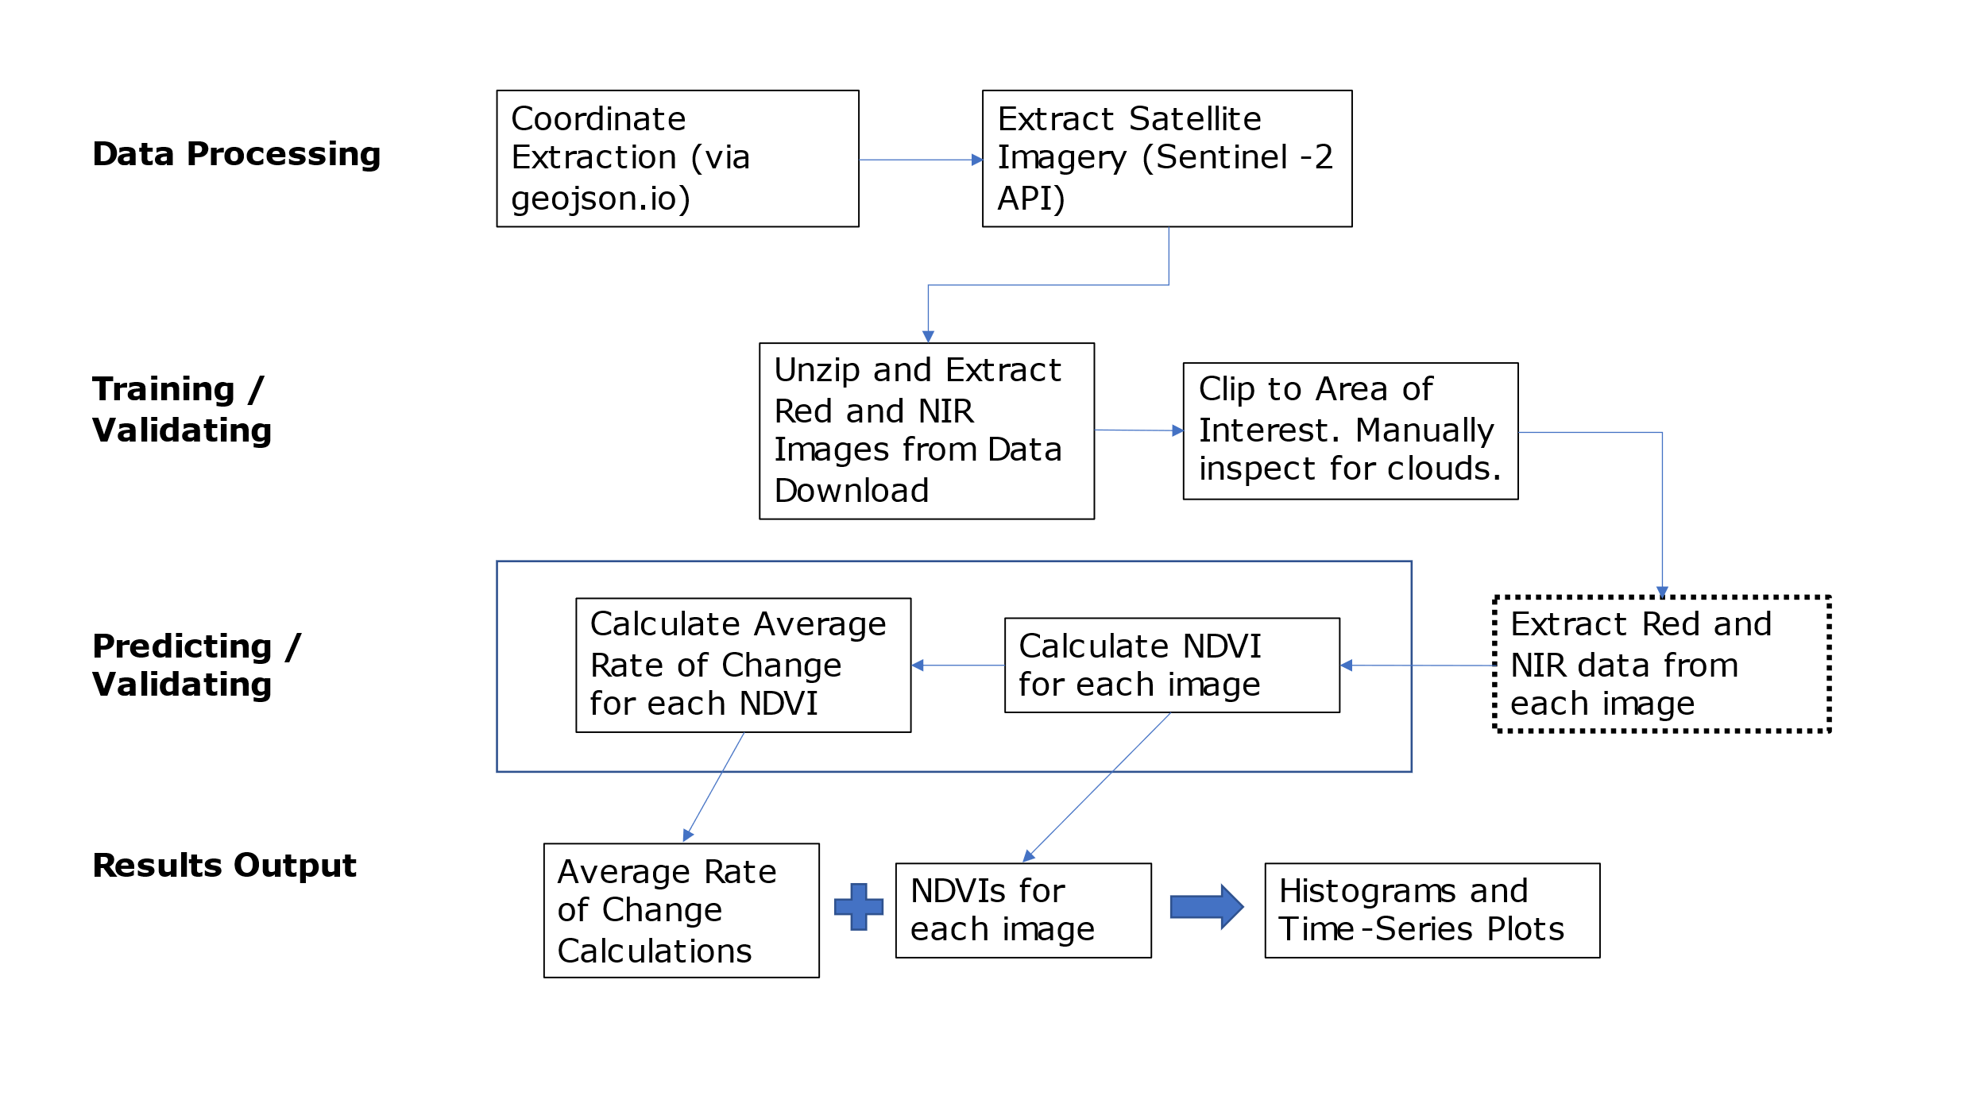

Figure 1. Methodology Box Diagram

**Data Preprocessing / Processing**

The Sentinel-2 images were pulled from the API using a GeoJson point object of the specified locations latitude and longitude coordinates. A 50% cloud coverage filter was included in the query parameters. When downloaded, another Python script was used to unzip the files and pull specifically the red and NIR bands from the folder into a separate folder and clipped to the specific area of interest. Then, each image was manually inspected to make sure none of the images contained clouds. The number of images selected depends on when the deforestation took place and ended and how big of a time span was in between.

**Training / Validation**

The red and NIR bands were pulled from each image, in chronological order, and the Normalized Difference Vegetation Index was computed using the data.

$$NDVI= \frac{R_{NIR}-R_{red}}{R_{NIR}+R_{red}}$$

**Prediction / Validation**

After the NDVI was calculated for each image, the average rates of changes were calculated. The NDVI of the first and second images were used for the numerator values and their corresponding indices were used for the denominator values.

$$Average Rate of Change= \frac{y}{x}= \frac{y_{2}-y_{1}}{x_{2}-x_{1}}=\frac{f\left(x_{1}\right)-f(x_{0})}{x_{1}-x_{0}}$$

**Results Output**

The results were several average rates of change calculations and NDVIs for each image. Additionally, a histogram and several time series plots were created using the red and NIR average pixel values. A standalone time series was created for the NDVI and average rate of change values.

**Data Sources**

The primary satellite images were obtained from the Sentinel-2 API, specifically the level-2A processing level which measures bottom of the atmosphere reflectance. The sensor details are listed in Table 1. Since only vegetation data is needed which can be measured using the Normalized Difference Vegetation Index, the Sentinel-2 is sufficient because of its common purposes is vegetation and burned area monitoring. The red and NIR bands were pulled in the training and validation state and calculated in the prediction and validation stage.

|  |  |  |  |
| --- | --- | --- | --- |
| **Sensor** | **Processing Level** | **Bands** | **Source** |
| Sentinel-2 | Level-2A | Red, NIR | [Sentinel-2 L1C (sentinel-hub.com)](https://docs.sentinel-hub.com/api/latest/data/sentinel-2-l1c/) |

Table 1. Sensor Data Information

**Results**

The area of interest boundaries used in the code to pull imagery from the Sentinel-2 API returned a dataset with 11 photos. After running a script to pull the NIR and red bands, the files were manually inspected one by one for changes in forest coverage. The files were clipped after selecting the coordinate boundaries and manually inspected again to remove the images still containing cloud coverage. Only four images were used in the analysis due to many of the clippings having lots of clouds: August 24th, September 13th, September 18th, and October 8th. The images are displayed as a GIF time series in Figure 2.

Figure 2. GIF Time-Series of Images (August to October 2022)

After clipping the images, the red and near infra-red values were pulled from each band and used to calculate the Normalized Difference Vegetation Index (NDVI). The distribution of these values is shown in the frequency tables in Figure 3. Unfortunately, due to the small number of images used in the analysis (four), the histograms do not sufficiently show the pixel value distributions well. More experiments will need to be done with more images in the time series for the histogram to show better red and NIR pixel value distributions. This form of representation helps visualize the various states of the vegetation across the time series (low red values and high NIR values results in a higher NDVI). The red bands are consistently distributed along the reflectance values indicating some form of change in reflectance values over time. The NIR values have a gap which indicates a large change in reflectance values somewhere in the time series. The values are also represented as a time series in Figure 4, which shows an overall decline in both red and NIR values.

*Figure 3. Red and NIR Pixel Value Frequency*

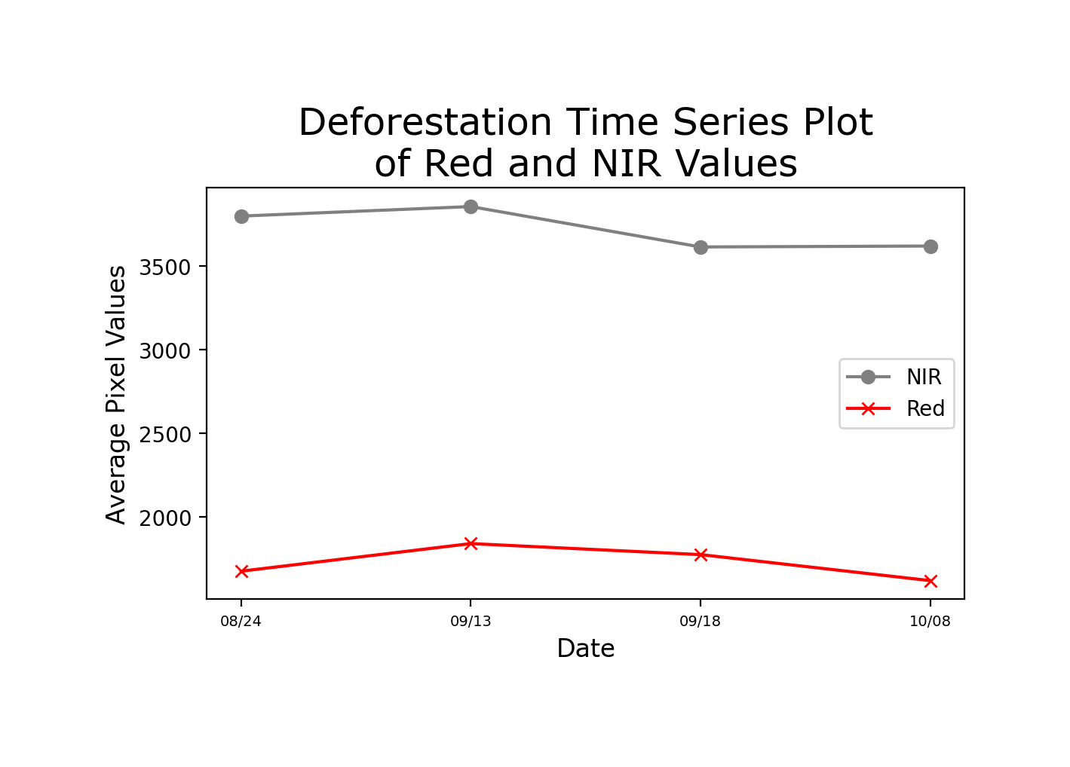

Figure 4. Red and NIR Pixel Value Time-Series

The NDVI values computed with the red and NIR values showed a decline in vegetation for the first three images and a sudden increase in the last image. The values declined by 4.6% from August 24th to September 18th and are followed by a 4% increase from September 18th to October 8th. These values can be seen in Figure 5 and the rate of change values, which follow a similar pattern, can be seen in Figure 6. Although the rate of change values follows a similar decline and increase pattern as the NDVI time-series shows, the significance of the changes is better reflected with the rate of change. The code automatically gave the first image a zero since there is no preceding image to calculate the rate with. The steepest change occurs later in the deforestation period from September 18th to October 8th. The standard maximum and minimum values for rate of change calculations is -1 to 1, but the range in this experiment only spanned from approximately -0.03 to 0.04. The average rate of change was -0.0015, which is low, but negative.

Figure 5. NDVI Time-Series

Figure 6. Rate of Change Time-Series

**Discussion**

The largest concern for this experiment was the lack of data available to be used due to the amount of cloud coverage in the images. Seven out of the eleven images had to be pulled from the analysis which interrupted the consistency of the time series. For example, the first and second image have a 19-day gap and the second and third image have a 5-day gap. This creates misleading graphs for the images with a smaller time gap because they will likely have experienced less change within a smaller time-period. This could be addressed by rerunning the code with a new area of interest with less cloud coverage so more of the images can be used and, in turn, narrow the time gap. Additionally, using a larger area experiencing forest loss and a larger time-period would create more results to analyze.

The increase in the first and second images, particularly after the deforestation began, could be because the second image in the time series still has some clouds in it. The haze creates whiter areas in the images and therefore, could potentially skew the red reflectance values. It is important for future research that the images have consistently minimal cloud coverage to ensure the reflectance values are more accurately represented. Due to the nature of the Amazon Rainforest being in a more tropical environment, the increased cloud coverage here presents one limitation of this analysis and future analyses that pull data from the Amazon.

**Conclusion**

The overall results of this research were limited by the choice in area of interest in the images downloaded and the cloud coverage. However, the code and methodology can be reused with new data for potentially better results. The results did show an overall decline in vegetation of approximately 4.6%, and an average rate of change of -0.0015. Although the value is small, it does indicate an overall decrease in vegetation. These calculations are useful for better understanding the process of deforestation in the Amazon such as, for the average rate of change, which time-period in the deforestation process experiences the most and least amount of change. In this area, the largest change in vegetation occurred in the first and last time-period interval. Although the unexpected increase in vegetation and change occurred in the last image, this does demonstrate the importance of clipping to areas of interest with no cloud coverage. To further restate the research question on which part of the deforestation process experiences the most change, the results show that the very beginning and very end of the process experienced the most change. However, because these values appear to be skewed from the clouds, more trials should be run with images with as minimal cloud coverage as possible to produce more accurate results.

**Bibliography**

Bolton, L. (2020). *Criminal Activity and Deforestation in Latin America*. https://doi.org/10.19088/K4D.2021.003

*Chapter 1: Framing and Context — Special Report on Climate Change and Land*. (n.d.). Retrieved November 14, 2022, from https://www.ipcc.ch/srccl/chapter/chapter-1/

Doaemo, W., Mohan, M., Adrah, E., Srinivasan, S., & Dalla Corte, A. P. (2020). Exploring Forest Change Spatial Patterns in Papua New Guinea: A Pilot Study in the Bumbu River Basin. *Land*, *9*(9), 282. https://doi.org/10.3390/land9090282

Ellwanger, J. H., Kulmann-Leal, B., Kaminski, V. L., Valverde-Villegas, J. M., Veiga, A. B. G. D., Spilki, F. R., Fearnside, P. M., Caesar, L., Giatti, L. L., Wallau, G. L., Almeida, S. E. M., Borba, M. R., Hora, V. P. D., & Chies, J. A. B. (2020). Beyond diversity loss and climate change: Impacts of Amazon deforestation on infectious diseases and public health. *Anais Da Academia Brasileira de Ciências*, *92*. https://doi.org/10.1590/0001-3765202020191375

Global Forest Watch. “Tree cover loss in Brazil”. Accessed on 17/11/2022 from www.globalforestwatch.org.

Heinimann, A., Mertz, O., Frolking, S., Egelund Christensen, A., Hurni, K., Sedano, F., Parsons Chini, L., Sahajpal, R., Hansen, M., & Hurtt, G. (2017). A global view of shifting cultivation: Recent, current, and future extent. *PLOS ONE*, *12*(9), e0184479. https://doi.org/10.1371/journal.pone.0184479

Kshetri, N., Rojas Torres, D. C., Besada, H., & Moros Ochoa, M. A. (2020). Big Data as a Tool to Monitor and Deter Environmental Offenders in the Global South: A Multiple Case Study. *Sustainability*, *12*(24), 10436. https://doi.org/10.3390/su122410436

Lanorte, A., Lasaponara, R., Lovallo, M., & Telesca, L. (2014). Fisher–Shannon information plane analysis of SPOT/VEGETATION Normalized Difference Vegetation Index (NDVI) time series to characterize vegetation recovery after fire disturbance. *International Journal of Applied Earth Observation and Geoinformation*, *26*, 441–446. https://doi.org/10.1016/j.jag.2013.05.008

Le Tourneau, F.-M. (2015). The sustainability challenges of indigenous territories in Brazil’s Amazonia. *Current Opinion in Environmental Sustainability*, *14*, 213–220. https://doi.org/10.1016/j.cosust.2015.07.017

McDowell, N. G., Coops, N. C., Beck, P. S. A., Chambers, J. Q., Gangodagamage, C., Hicke, J. A., Huang, C., Kennedy, R., Krofcheck, D. J., Litvak, M., Meddens, A. J. H., Muss, J., Negrón-Juarez, R., Peng, C., Schwantes, A. M., Swenson, J. J., Vernon, L. J., Williams, A. P., Xu, C., … Allen, C. D. (2015). Global satellite monitoring of climate-induced vegetation disturbances. *Trends in Plant Science*, *20*(2), 114–123. https://doi.org/10.1016/j.tplants.2014.10.008

Monteiro, M. S. A., Seixas, S. R. da C., & Vieira, S. A. (2014). The politics of Amazonian deforestation: Environmental policy and climate change knowledge. *WIREs Climate Change*, *5*(5), 689–701. https://doi.org/10.1002/wcc.298

Nobre, C. A., Sampaio, G., Borma, L. S., Castilla-Rubio, J. C., Silva, J. S., & Cardoso, M. (2016). Land-use and climate change risks in the Amazon and the need of a novel sustainable development paradigm. *Proceedings of the National Academy of Sciences*, *113*(39), 10759–10768. https://doi.org/10.1073/pnas.1605516113

Oliveira, J., Oliveira, V., Vitor, J., Silva, G., Do, W., Santana, R., Salomão, B., Lima, A., Altoé, J., Batista, A., Alexandre, M., Amourim, A., Yogesh, & Agarwal, K. (2020). *Article no.IJPSS.62050 Review Article Oliveira et al*. 1–12.

Peng, W., Sonne, C., Lam, S. S., Ok, Y. S., & Alstrup, A. K. O. (2020). The ongoing cut-down of the Amazon rainforest threatens the climate and requires global tree planting projects: A short review. *Environmental Research*, *181*, 108887. https://doi.org/10.1016/j.envres.2019.108887

Posada-Marín, J. A., & Salazar, J. F. (2022). River flow response to deforestation: Contrasting results from different models. *Water Security*, *15*, 100115. https://doi.org/10.1016/j.wasec.2022.100115

Schüßler, D., Link to external site, this link will open in a new window, Lee, P. C., & Stadtmann, R. (2018). Analyzing land use change to identify migration corridors of African elephants (Loxodonta africana) in the Kenyan-Tanzanian borderlands. *Landscape Ecology*, *33*(12), 2121–2136. https://doi.org/10.1007/s10980-018-0728-7

Urrutia-Pereira, M., Rizzo, L. V., Chong-Neto, H. J., & Solé, D. (2021). Impact of exposure to smoke from biomass burning in the Amazon rain forest on human health. *Jornal Brasileiro de Pneumologia*, *47*. https://doi.org/10.36416/1806-3756/e20210219

Vale, P., Gibbs, H., Vale, R., Munger, J., Brandão, A., Christie, M., & Florence, E. (2019). Mapping the cattle industry in Brazil’s most dynamic cattle-ranching state: Slaughterhouses in Mato Grosso, 1967-2016. *PLOS ONE*, *14*(4), e0215286. https://doi.org/10.1371/journal.pone.0215286

Vizzuality. (n.d.). *Global Deforestation Rates & Statistics by Country | GFW*. Retrieved November 16, 2022, from https://www.globalforestwatch.org/dashboards/global

Winkler, K., Link to external site, this link will open in a new window, Fuchs, R., Link to external site, this link will open in a new window, Rounsevell, M., Herold, M., & Link to external site, this link will open in a new window. (2021). Global land use changes are four times greater than previously estimated. *Nature Communications*, *12*(1), 2501. https://doi.org/10.1038/s41467-021-22702-2